Women Making Waves

Photo from display followed by the text that was taped to the board. Index cards were provided for people to add names that weren’t already included.

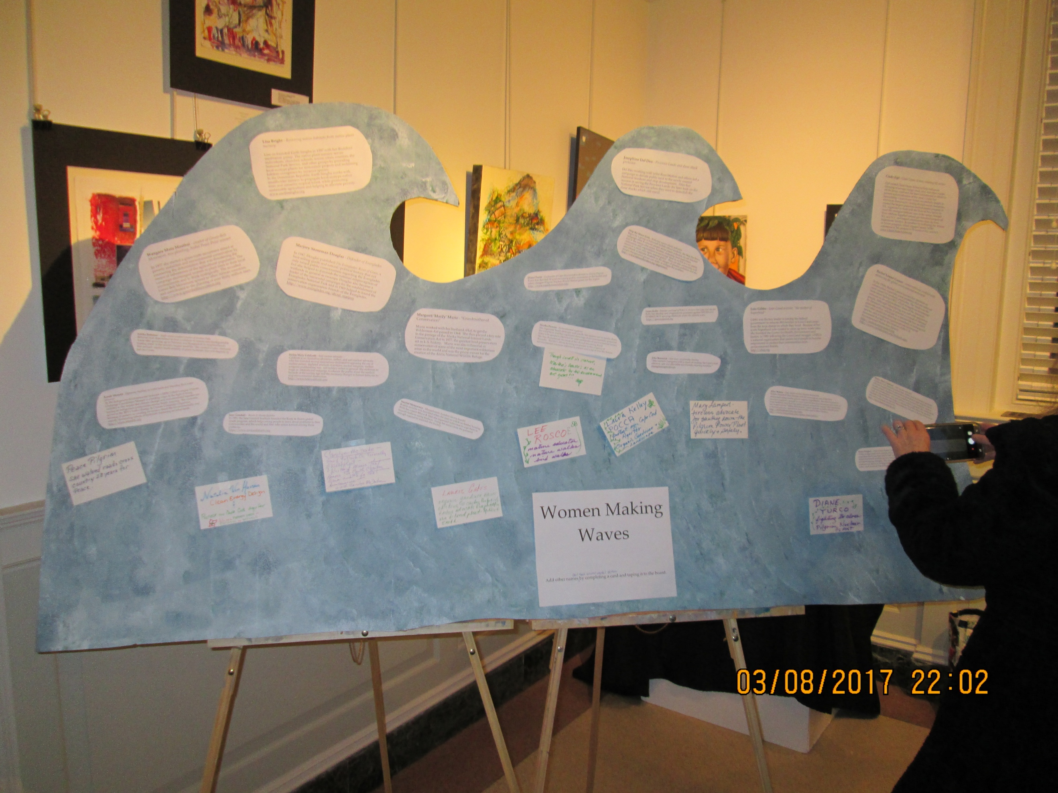

Josephine Del Deo - Province Lands and dune shack protector.

Del Deo working with artist Ross Moffett and others led a campaign to donate public land to the newly created National Seashore and stop development. After her success in saving the Province Lands she later took on the National Park Service when they tried to demolish the dune shacks which still stand.

Rachel Louise Carson - conservationist credited with advancing the global environmental movement

In the 1950s, Rachel Carson focused her attention on conservation, especially some problems that she believed were caused by synthetic pesticides. The result was the book Silent Spring (1962), which brought environmental concerns to an unprecedented share of the American people. Although Silent Spring was met with opposition by chemical companies, it spurred a reversal in national pesticide policy, which led to a nationwide ban on DDT and other pesticides allowing a comeback of endangered species, and it inspired a grassroots environmental movement that led to the creation of the U.S. Environmental Protection Agency.
http://rachelcarsoncouncil.org http://www.rachelcarson.org/Default.aspx

Wangara Muta Maathai - creator of Green-Belt Movement, tree planting, Nobel Peace Prize winner

In 1977 she started a grass-roots movement aimed at poverty reduction and environmental conservation by countering the deforestation that was threatening the means of subsistence of the agricultural population. The campaign encouraged women to plant trees in their local environments and to think ecologically. The so-called Green Belt Movement spread to other African countries, and contributed to the planting of over thirty million trees.
http://www.greenbeltmovement.org

Lisa Bright - Restoring native habitats from native plant nursery

Lisa co-founded Earth Sangha in 1997 with her Buddhist meditation group. The native plant nursery serves individuals, churches, schools, towns, cities, counties, the National Park Service, and other groups by providing local-ecotype plants for restoration projects and reclaiming habitats overgrown by invasive species.
In the Dominican Republic, Earth Sangha works with smallholder farmers to propagate local-ecotype native trees and conserve tropical forest, while promoting sustainable agriculture and helping to alleviate poverty.
www.earthsangha.org

Diane Turco - Co-founder of Cape Downwinders devoted to closing Pilgrim
Turco has devoted 30 years to raising public awareness on the health and safety dangers Pilgrim Nuclear Power Station poses for the region.
http://www.capedownwinders.info

Lois Gibbs - Love Canal activist, “the mother of Superfund”

Gibbs was the key leader in forcing the federal government to relocate 883 families in Love Canal away from the toxic dump on which they lived. Because of her work Superfund was created to clean up toxic waste sites. She founded the Center for Health, Environment and Justice, in 1981 following the Love Canal struggle. CHEJ is a national organization that assists local people to become empowered to protect their communities from environmental threats.
http://chej.org

Alice Waters - Chef, owner of Chez Panisse Restaurant
Waters founded Chez Panisse over 40 years ago as one of the first restaurants using locally grown, organic ingredients. She tries to preserve local food traditions through her work with the slow food movement and works to bring healthful, local food into public schools around the country. Her foundation has created several "Edible Schoolyards," where students at public schools learn to harvest and grow ingredients that are then used in their lunches.
http://edibleschoolyard.org/team
http://www.chezpanisse.com/about/alice-waters/

Marjory Stoneman Douglas - Defender of Everglades

In 1947, Douglas published The Everglades: River of Grass, a best-selling guide and natural/political history that not only raised public consciousness regarding the Everglades but also helped to diminish the national misperception of wetlands in general as swamps. Douglas also became a leader of the successful campaign for the establishment of Everglades National Park and in 1969 helped to found the conservation organization Friends of the Everglades.
http://www.everglades.org/about_marjory

Cindy Zipf - Clean Ocean Action, cleaning NJ oceans

Zipf created Clean Ocean Action to help end ocean dumping of sewage sludge, mud, acid, and other wastes off the Jersey coast and has been instrumental in efforts to prevent industrialization of the ocean. Under her stewardship, Clean Ocean Action successfully fought to end ocean dumping by closing all eight ocean dumpsites, created the largest grassroots environmental program in N.J., organized to work with the State of New Jersey to enact the strongest fertilizer laws in the nation, blocked three offshore liquefied natural gas industrial projects off N.J. and N.Y. and helped communities clean-up from Superstorm Sandy’s devastation by instituting the Waves of Action program, which engaged nearly 14,000 volunteers in 281 projects in 70 towns in N.J. and N.Y.
www.CleanOceanAction.org

Helen Mary Caldicott - Anti nuclear advocate
Caldicott is an Australian physician, author, and anti-nuclear advocate who has founded several associations dedicated to opposing the use of nuclear power, depleted uranium munitions, nuclear weapons, nuclear weapons proliferation, war, and military action in general. She continues to wage an international campaign to educate the public about the medical hazards of the nuclear age and the necessary changes in human behavior to stop environmental destruction.
http://www.helencaldicott.com

Jitka Borowick - Non-toxic, eco-friendly cleaning
“Jitka started Cleangreen with a vision of creating the Cape’s most effective, safe and affordable eco-friendly cleaning business.”
cleangreencapecod.com.

Kandi Mossett - Opposing fracking on tribal lands and Standing Rock water protector
As the Indigenous Environmental Network’s (IEN) Tribal Campus Climate Challenge Coordinator Mossett is a leading voice in the fight to bring
visibility to the impact that climate change and environmental injustice are having on indigenous communities across North America. She currently serves as the IEN’s Native Energy & Climate Campaign Organizer, focusing at present on creating awareness about the environmentally and socially devastating effects of hydraulic fracturing on tribal lands.
http://www.ienearth.org

Saliha Rehanaz - High school student creator of Sreshto Pads
Rehanaz was determined to find a solution to reduce non-biodegradable waste after growing up in Pakistan and Bangladesh in neighborhoods hosting some of the world’s largest landfills. She created a safer, chemical-free sanitary napkin made entirely of plant materials that will degrade in just two years.

Jane Goodall - Roots & Shoots founder
In 1991, the Jane Goodall Institute founded the Roots & Shoots global youth program, which helps young people to learn about problems in their communities and the world and then take action toward solving those problems.
https://www.rootsandshoots.org

Martha Powers - Environmental organizer
She organizes beach cleanups with youth, has spoken out to media about the wind farm and has organized showings of environmentally powerful films with speakers afterward to raise awareness of environmental issues. She has championed the cause of her church becoming Earth Friendly. Martha's efforts to bring awareness to the urgency of environmental concerns continue to inform and inspire into the future.

Skip the Straw Girls - Reducing marine plastic pollution
Begun by a group of Falmouth middle school students, the Skip the Straw campaign aims to educate people about plastic pollution on our beaches and in the oceans. One action has been contacting local businesses, restaurants, and organizations to encourage them to switch to a no plastic straws or a straw only upon request policy. They are also connecting with area schools to educate students on the danger of plastics pollution and the simple changes each person can make to mitigate the problem.
http://www.falmouthwaters.org/skipstraws/
The following are the honorees from the evening. These placards were displayed near the “wave”.

International Women’s Day 2017 Honoree

Lynne Cherry
Author, filmmaker, climate change educator, founder of Young Voices on Climate Change

A resident of Falmouth and a visiting scholar at the Woods Hole Research Center, Lynne has focused her talent and experience as an author/illustrator of 30 award-winning children’s books on teaching about climate change with hope and solutions. She is the producer and director of the Young Voices for the Planet film series that champions youth solutions to the climate crisis and inspires other youth to take action.
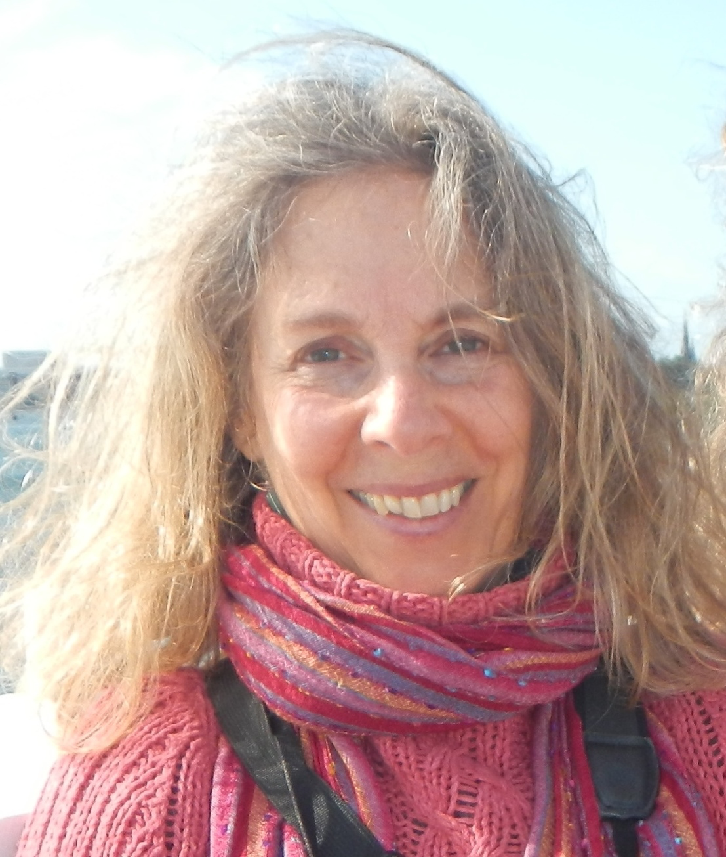

http://www.youngvoicesonclimatechange.com/

Women’s International League for Peace and Freedom
International Women’s Day 2017 Honoree

Ramona Peters
Tribal Historic Preservation Officer,
Founder of Native Land Conservancy

Ramona Peters, whose Wampanoag name is Nosapocket, is an artist, historian, teacher, writer, cultural consultant, curator, and activist. As the Tribal Historic Preservation Officer and Director of the Native American Graves and Repatriation Act for the Mashpee Wampanoag Tribe, she has worked with Cape Cod Conservation Trusts to develop the Native Land Conservancy. Ramona has led an ongoing effort to save open space that preserves the essence of native history and sustains Cape Cod’s unique beauty and fosters learning about First People’s spirit and history.
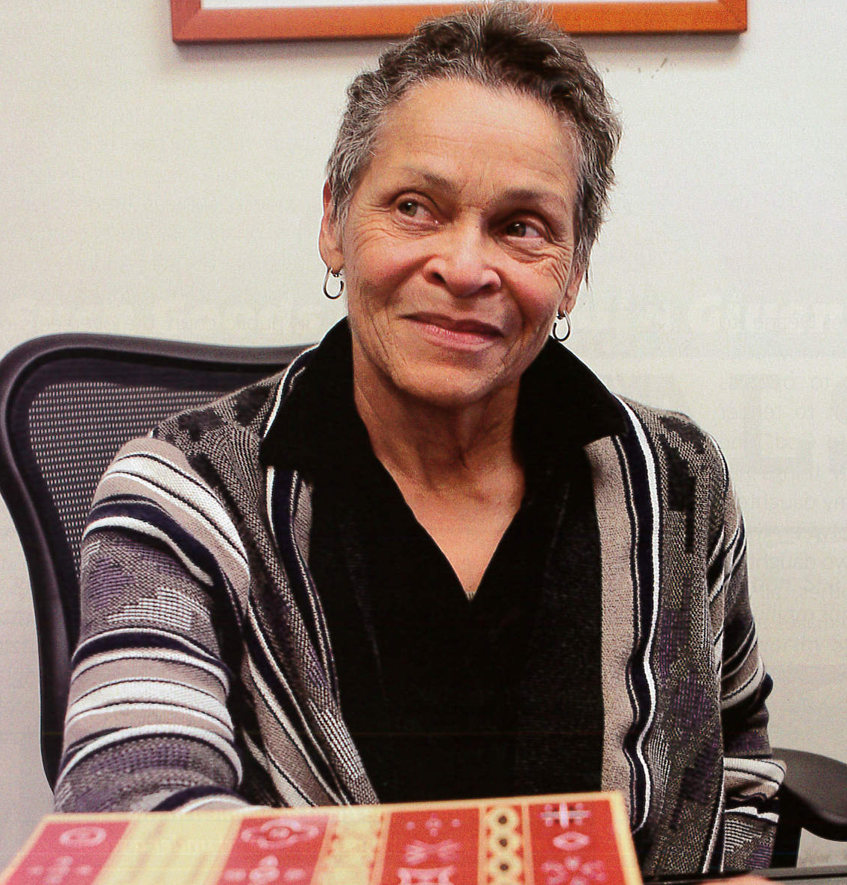
photo from Plimoth Life Magazine v.13, no.1, 2014
http://www.nativelandconservancy.org

Women’s International League for Peace and Freedom
International Women’s Day 2017 Honoree

Francie Randolph
Artist and Educator, Co-founder of the Truro Agricultural Fair, Creator of Sustainable CAPE (Center for Agricultural Preservation & Education)

On a small farm in Truro, Francie combines her passions for art, food, health, the environment, community-building, and education. Sustainable CAPE’s mission is to grow and celebrate local food while teaching about the health of our bodies, communities, and environment – thereby creating a decidedly more delicious, healthy and sustainable world.
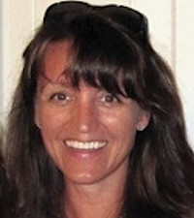
http://www.SustainableCAPE.org
francie@sustainablecape.org 774-383-2169
Women’s International League for Peace and Freedom
International Women’s Day 2017 Honoree

Sue Phelan
Organic Gardener, Beekeeper, Founder and Director of GreenCAPE

Sue Phelan has grown GreenCAPE from a neighborhood effort to reduce the indiscriminate use of pesticides in 1998 to a powerful community advocacy organization influencing policies Cape-wide. GreenCAPE educates the public about the hazards of pesticides, herbicides and other toxins and provides information on least-toxic alternatives, including safer cosmetics, cleaning products, and lawn and garden care. GreenCAPE works on public policies to address issues such as PFA contamination of drinking water, contaminated play areas, and tick- and mosquito-borne diseases.

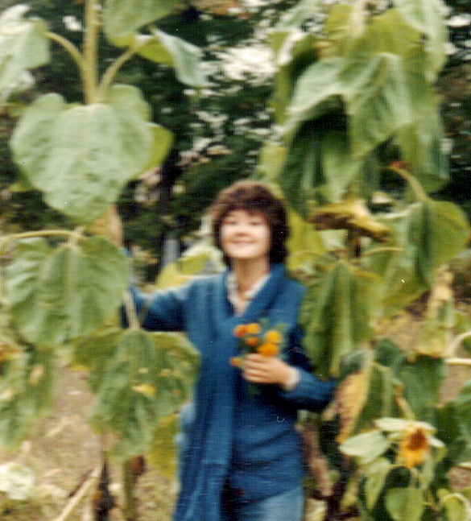

http://www.GreenCAPE.org

Women’s International League for Peace and Freedom
International Women’s Day 2017 Honoree

Sheila Place
UU Activist, Co-Chair of Cape Environmental Action, Leader of the Ban the Bag Movement

Sheila has combined her skills and experience in community leadership with her love of the outdoors and commitment to environmental issues through her leadership of the Ban the Bag movement on Cape Cod that was initiated in 2014 by Cape Environmental Action – a collaborative of Unitarian churches in Brewster, Falmouth, and Barnstable. Currently, 11 of 15 Cape Cod towns have passed bans on the use of plastic bags made from fossil fuels. Further action should soon spread the ban throughout Cape Cod.

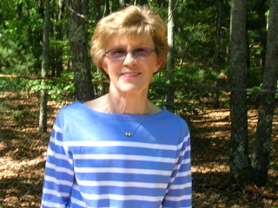

sbplace583@gmail.com

Women’s International League for Peace and Freedom

