Photo of Food Choices poster followed by text

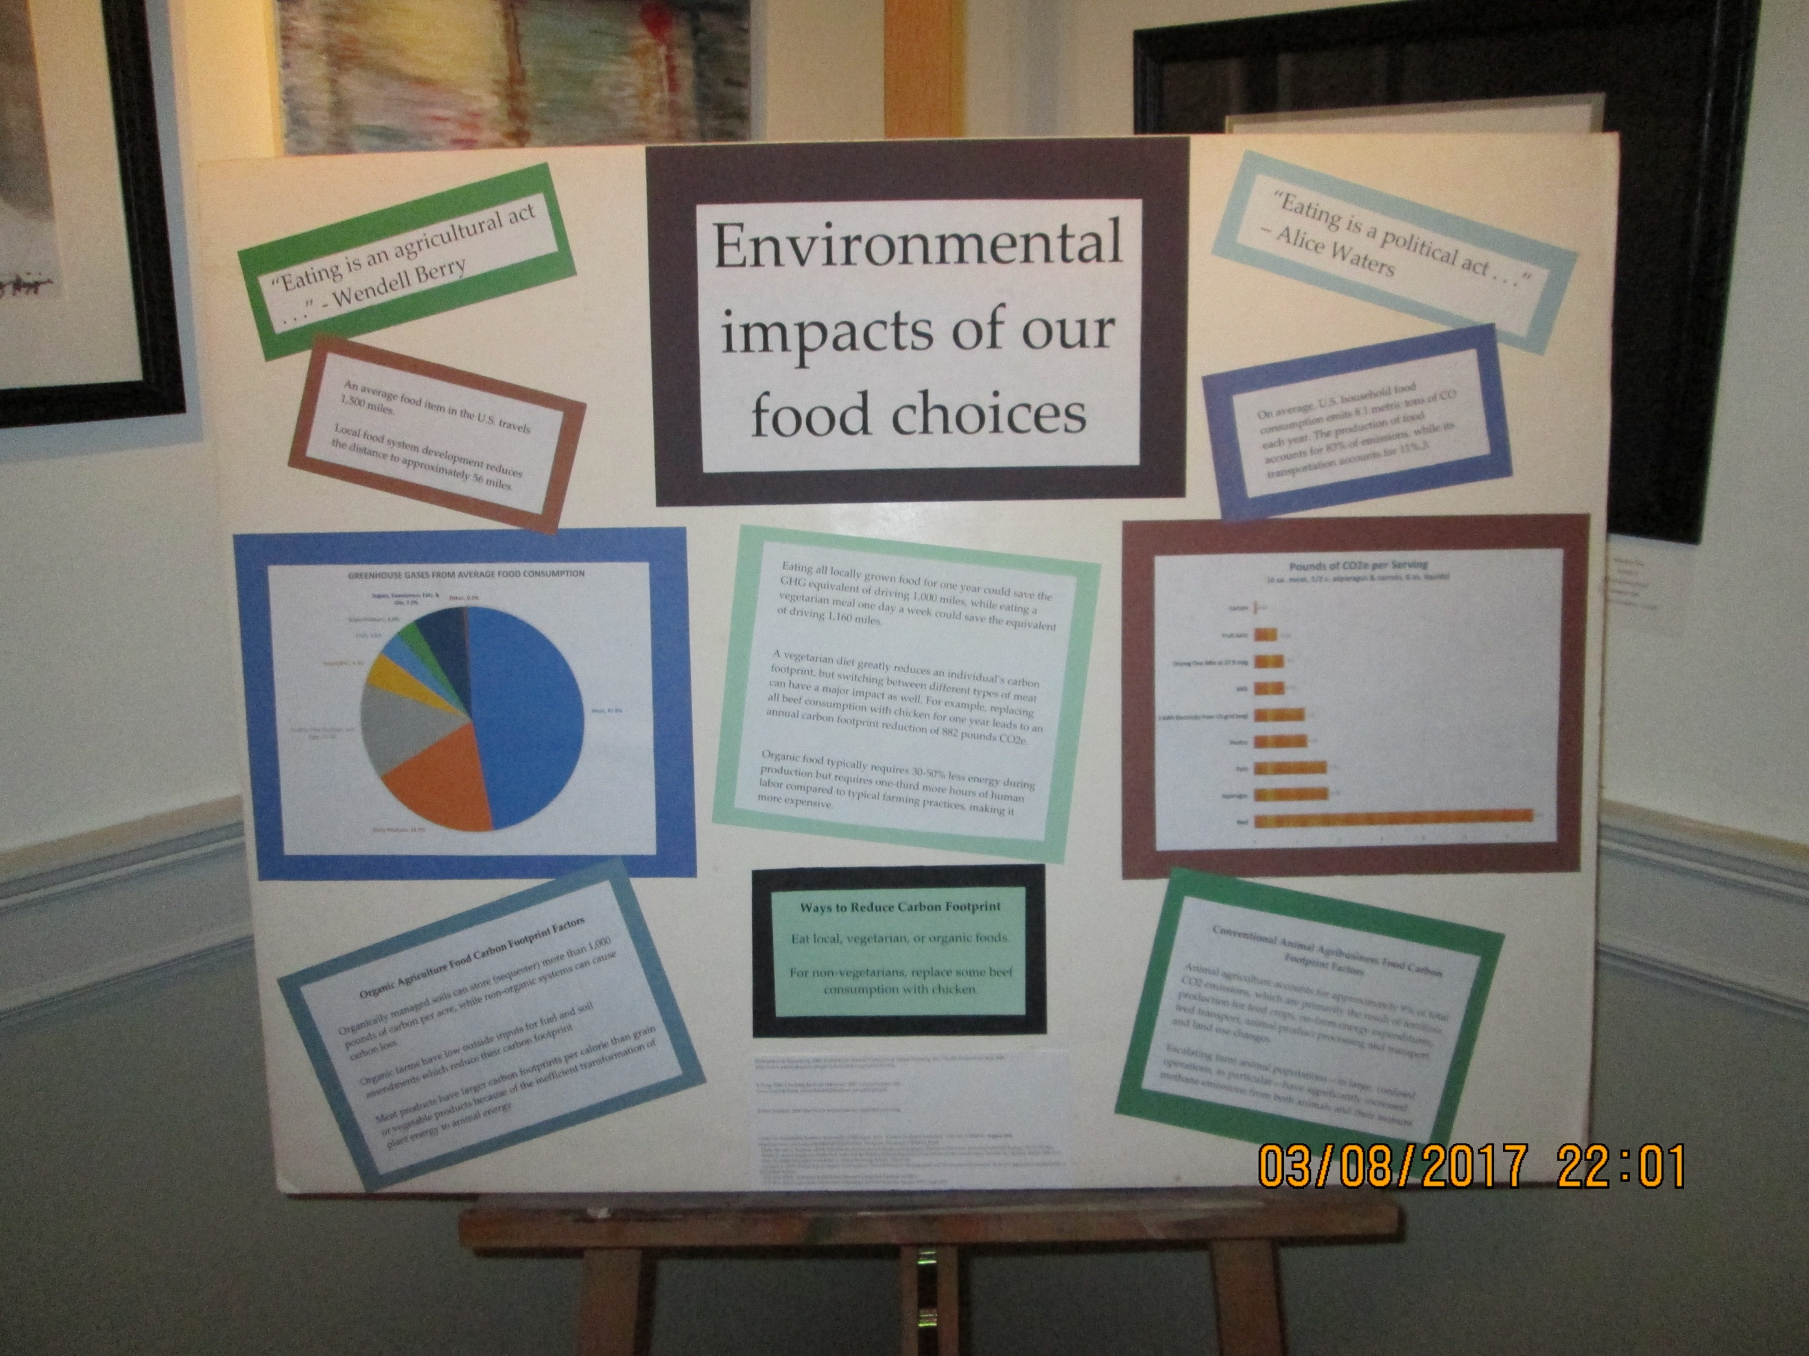

Conventional Animal Agribusiness Food Carbon Footprint Factors

Animal agriculture accounts for approximately 9% of total CO2 emissions, which are primarily the result of fertilizer production for feed crops, on-farm energy expenditures, feed transport, animal product processing and transport, and land use changes.

Escalating farm animal populations—in large, confined operations, in particular—have significantly increased methane emissions from both animals and their manure.
Koneswaran & Nierenberg, 2008, Global Farm Animal Production & Global Warming, Env. Health Perspectives May 2008 http://www.pubmedcentral.nih.gov/articlerender.fcgi?artid=2367646

Statistics of Average U.S. Food Carbon Footprint Per Household
Impact of your food purchase decisions.
Purchasing local foods is only a partial solution.
Purchasing foods that are produced using sustainable
and organic agriculture practices is a better solution.
http://sarasota.ifas.ufl.edu/AG/FoodChoiceCarbon.pdf

Organic Agriculture Food Carbon Footprint Factors

Organically managed soils can store (sequester) more than 1,000 pounds of carbon per acre, while non-organic systems can cause carbon loss.*

Organic farms have low outside inputs for fuel and soil amendments which reduce their carbon footprint
* Rodale Institute, 2008 http://www.rodaleinstitute.org/global_warming

On average, U.S. household food consumption emits 8.1 metric tons of CO each year. The production of food accounts for 83% of emissions, while its transportation
accounts for 11%.3.

Meat products have larger carbon footprints per calorie than grain or vegetable products because of the inefficient transformation of plant energy to animal energy.
Center for Sustainable Systems, University of Michigan. 2016. “Carbon Footprint Factsheet.” Pub. No. CSS09-05. August 2016
http://css.snre.umich.edu/sites/default/files/Carbon_Footprint_Factsheet_CSS09-05_0.pdf

Eating all locally grown food for one year could save the GHG equivalent of driving 1,000 miles, while eating a vegetarian meal one day a week could save the equivalent of driving 1,160 miles.

A vegetarian diet greatly reduces an individual’s carbon footprint, but switching between different types of meat can have a major impact as well. For example, replacing all beef consumption with chicken for one year leads to an annual carbon footprint reduction of 882 pounds CO2e.

Organic food typically requires 30-50% less energy during production but requires one-third more hours of human labor compared to typical farming practices, making it more expensive.

Ways to Reduce Carbon Footprint
Eat local, vegetarian, or organic foods. For non-vegetarians, replace some beef consumption with chicken.
Center for Sustainable Systems, University of Michigan. 2016. “Carbon Footprint Factsheet.” Pub. No. CSS09-05. August 2016
http://css.snre.umich.edu/sites/default/files/Carbon_Footprint_Factsheet_CSS09-05_0.pdf

