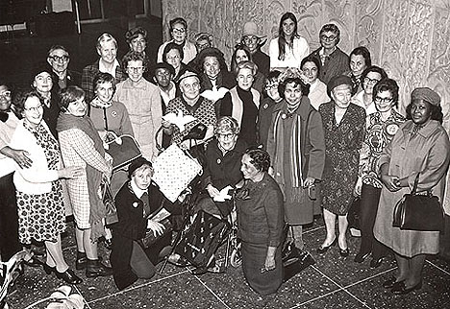

#E2 23rd International WILPF Congress, New Delhi (India),
Dec. 28, 1970 - Jan. 02, 1971: U.S. Delegation

