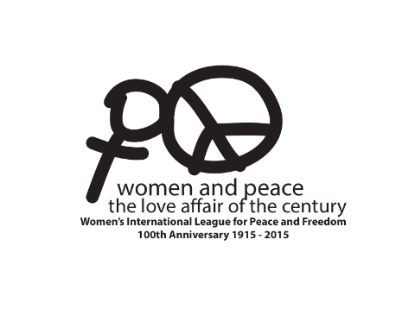
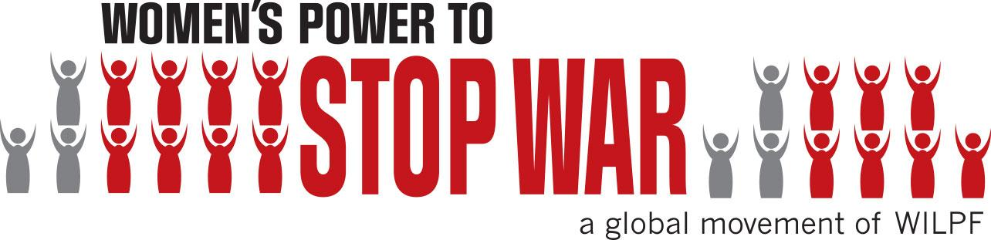

MEDIA ADVISORY FOR: WEDNESDAY, MARCH 11

CONTACT: Shayna Samuels, 718-541-4785, shayna@ripplestrategies.com
Glenn Turner, 917-817-3396, glenn@ripplestrategies.com

100th Anniversary of International Women’s Peace Organization to be Celebrated at the New York Public Library

Founded to Stop WWI, Group Continues to Promote
New Approaches to Peace and Advancing the Rights of Women Worldwide
The Women’s International League for Peace and Freedom (WILPF) – the oldest women’s peace organization with branches in 30 countries – is celebrating a century of peacebuilding with events around the world – including one in New York City. In 1915, 1,200 women from a diversity of cultures and languages came together in The Hague during World War I to eliminate the causes of war. Out of this meeting WILPF was born, and has since been working for peace and freedom by claiming women’s right and responsibility to participate in decision-making on all aspects of peace and security.
WILPF’s first International President Jane Addams was received by President Woodrow Wilson and became the first American woman to win a Nobel Peace Prize in 1931. Emily Greene Balch, WILPF’s first International Secretary, received the prestigious award in 1946 in part for warning against fascism, and criticizing the western democracies for not attempting to stop Hitler's and Mussolini's aggressive policies.
During its lifetime WILPF has organized dialogues between women in the Middle East, sent delegations of women to North and South Vietnam to oppose the Vietnam War, and worked closely with the UN nearly 15 years ago to establish the first women, peace and security resolution (UN Security Council Resolution 1325) to ensure women’s full participation in all conflict prevention, peacebuilding, and post-conflict reconstruction processes. From April 27 – 29, 2015 an international conference will take place 100 years later at The Hague, during which WILPF’s International’s global campaign, Women’s Power to Stop War, will be launched.

WHAT: 100th Anniversary Celebration of the Women’s International League for Peace and Freedom, featuring the New York Public Library’s exhibition of the Schwimmer-Lloyd Collection of early WILPF and WWI newspaper clippings, reports and photographs assembled by WILFP founders Rosika Schwimmer of Hungary and Lola Maverick Lloyd of the U.S.. There will also be a performance by Robin Lloyd and Charlotte Dennett entitled, “Talking With Our Grandmothers,” in which they share history of war and the Women's Peace movement through conversations with and about their Grandmothers.

WHEN: Wednesday, March 11, 5:00 – 7:30pm

WHERE: The New York Public Library, Stephen A. Schwarzman Building
42nd Street and 5th Ave. (South Court Auditorium), New York City

WHO: International WILPF Secretary-General Madeleine Rees, who previously served as the Head of the Women’s Rights and Gender Unit for the Office of the High Commissioner for Human Rights, will give a keynote address on issues facing women in the Middle East.
WILPF US President, Mary Hansen Harrison
WILPF Historians: CUNY professor Harriet Alonso, author of Peace as a Women's Issue; and Wellesley Professor Catia Confortini, author of Intelligent Compassion: Feminist Critical Methodology in the Women's International League for Peace and Freedom
Editor and Publisher of The Nation Katrina vanden Heuvel

HOW: This event is free and open to the public. Members of the press should RSVP to Shayna Samuels: Shayna@ripplestrategies.com or 718-541-4785

ATTENTION REPORTERS: Advance interviews are available with International WILPF Secretary-General Madeleine Rees and US WILPF President Mary Hansen Harrison. Historical photos are also available here. Please contact Shayna Samuels for more information at 718-541-4785 or shayna@ripplestrategies.com

# # #

